Hoàng Văn Khang 20210466

OOP lab week 5: GUI programming

**Part 1: Swing components:**

* 1. AWTAccumulator:

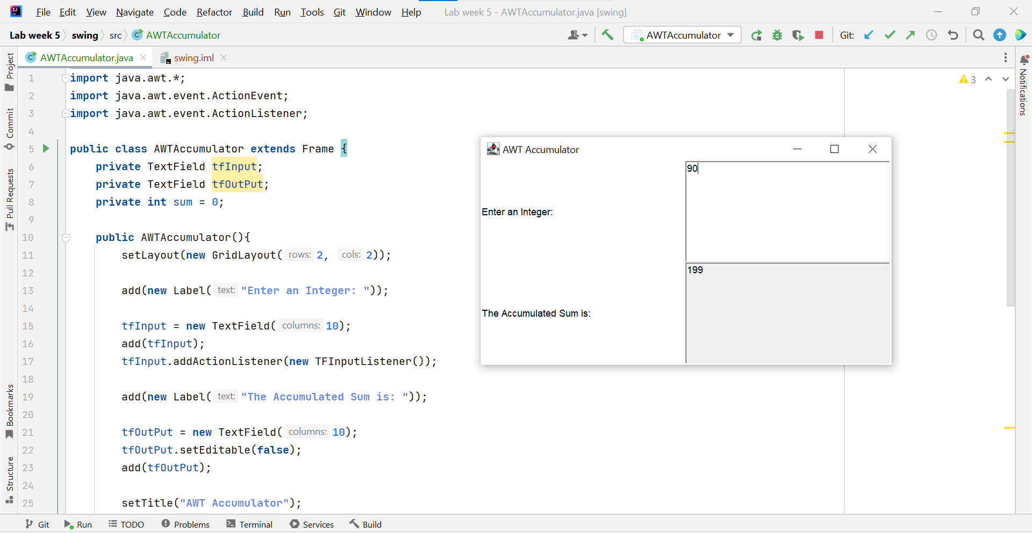

* 1. SwingAccumulator:

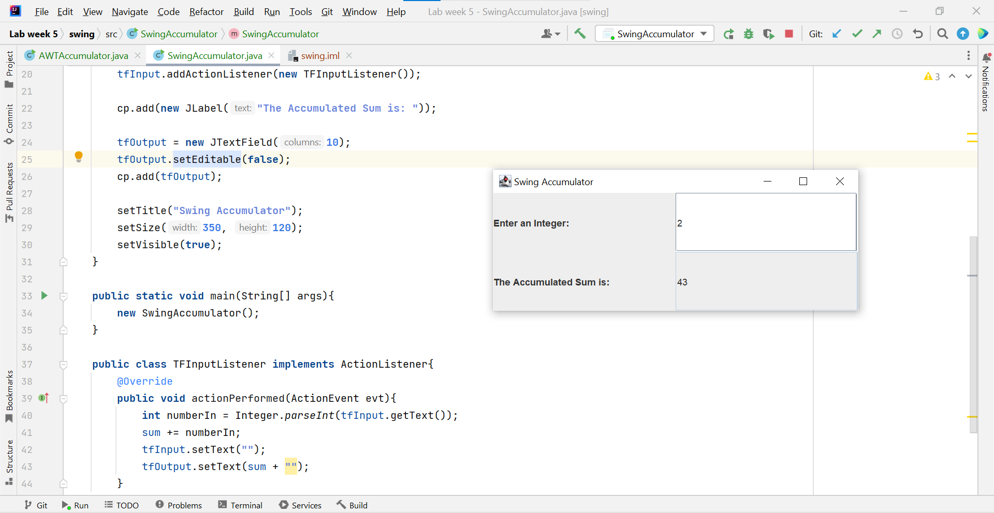

**Part 2: Organize Swing components with Layout Manager:**

2.1. Swing top-level and secondary-level containers:

2.2. Using Jpanel as secondary-level container to organize components:

2.2.1. Create class NumberGrid:

2.2.2. Adding buttons:

2.2.3. Complete inner class ButtonListener:

**Part 3: Create a graphical user interface for AIMS with Swing:**

3.1. View Store Screen:

3.1.1. Create the StoreScreen class:

3.1.2. The NORTH component:

3.1.3. The CENTER component:

3.1.4. The MediaStore class:

3.1.5. Putting it together:

3.2. Adding more user interaction:

**Part 4: JavaFX API:**

4.1. Create FXML file:

4.1.1. Create and open FXML file in Scene Builder:

4.1.2. Building the GUI:

4.2. Create the controller class:

4.3. Create the application:

4.4. Practice exercise:

**Part 5: Setting up the View Cart Screen with SceenBuilder:**

5.1. Setting up the BolderPane:

5.2. Setting up the TOP area:

5.3. Setting up the CENTER area:

5.4. Setting up the RIGHT area:

**Part 6: Integrating JavaFX into Swing application – The JFXPanel class:**

**Part 7: View the items in cart – JavaFX’s data driven UI:**

**Part 8: Updating buttons based on selected item in TableView – ChangeListener**

**Part 9: Deleting a media:**

**Part 10: Filter items in cart – FilteredList:**

**Part 11: Complete the Aims GUI Application:**

**Part 12: Check all the previous source codes to catch/handle/delegate runtime exceptions:**

**Part 13: Create a class which inherits from Exception:**

13.1. Create new class named PlayerException:

13.2. Raise the PlayerException in the play() method:

13.3. Update play() in the Playable interface:

13.4. Update play() in CompactDisc:

**Part 14: Update the Aims class:**

**Part 15: Modify the equals() method of Media class:**

**Part 16: Reading document:**

**Part 17: Update Aims class diagram:**